Study guide terms

- KNOW - highest level

- UNDERSTAND - don’t need to know specifics, but understand how the pieces come together

- BE FAMILIAR WITH - lowest; just know the idea behind a word

​

## Computer Networks and the Internet

**- Know the networking stack**

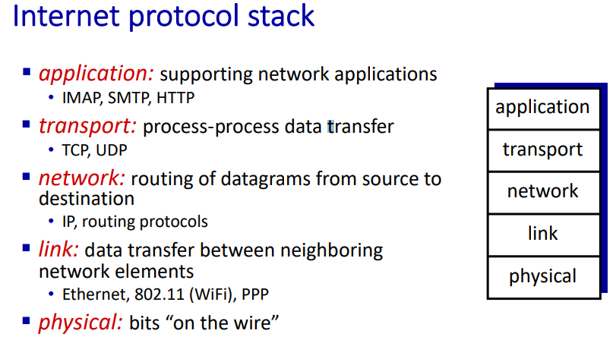

- Be familiar with how routers work

**Packet switches: forward**

**packets (chunks of data)**

**§ routers, switches**

- Understand the different components of end-to-end delay of a packet

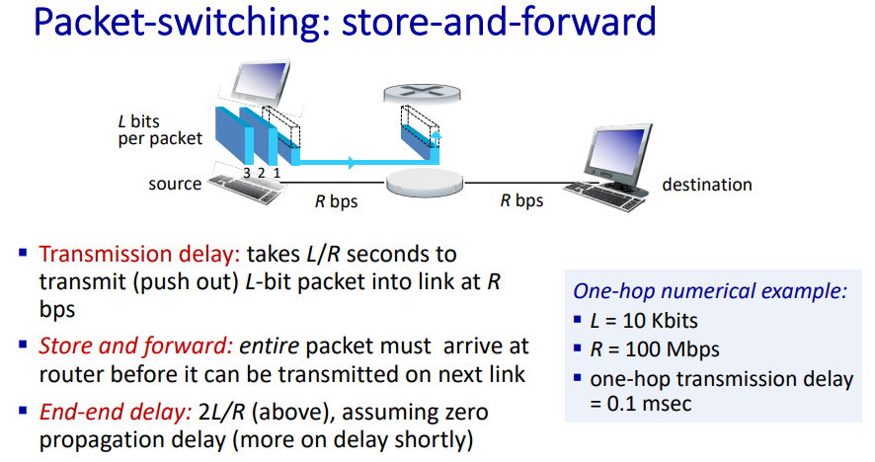

- Know how to calculate end-to-end delay

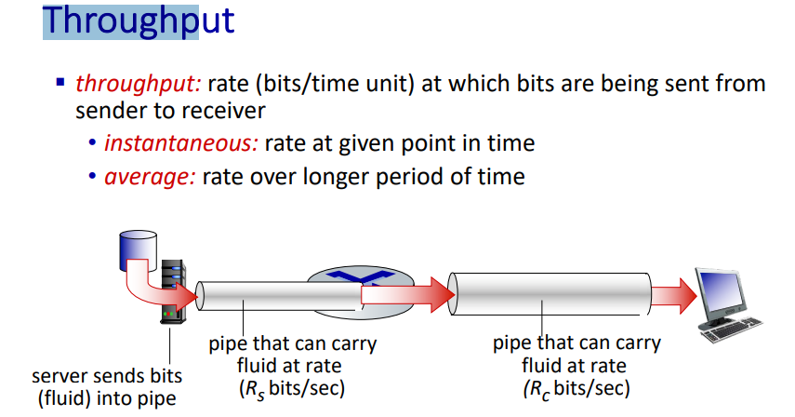

- Know how to calculate throughput and when a bottle neck occurs

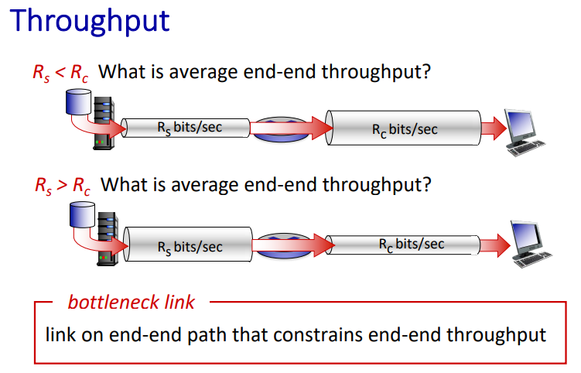

​

## Application Layer

- Know what services the application layer provides

- Know the specifics of HTTP

**Uses TCP, stateless(no past client request info)**

**Persistent and Non-Persistent**

**two types of HTTP messages: request, response**

**Post, head, put, get**

**Non-persistent HTTP response time = 2RTT+ file transmission time**

- Understand how SMTP works

**simple mail transfer protocol:**

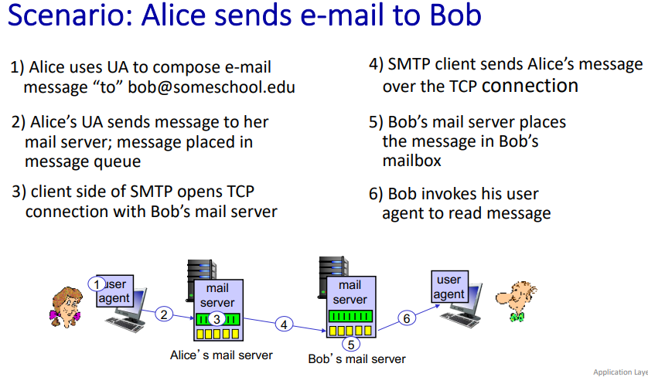

- Know what services DNS provides and how it works

**Domain Name System**

**query and reply**

**implemented as application-layer protocol**

- Understand how P2P networks work and why they are better than regular networks for certain tasks

**self scalability – new peers bring new service capacity, and new service demands**

**no always-on server**

**time to send one copy: F/us •**

**time to send N copies: NF/us**

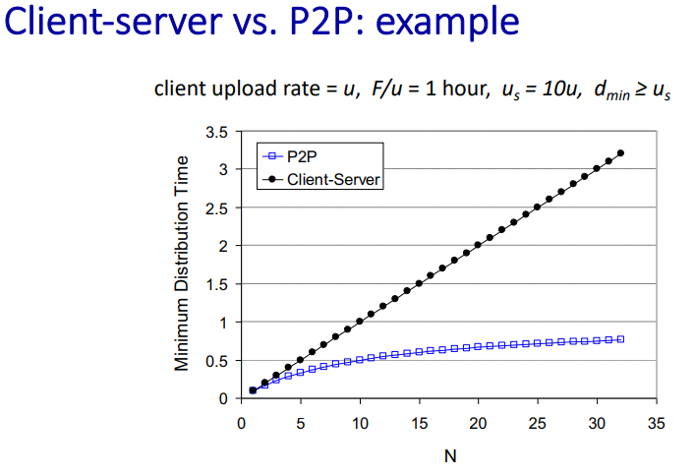

- Understand how HTTP streaming and DASH work

- Know about CDNs

**content distribution networks**

**distributed, application-level infrastructure**

**constant(SBR) vs variable(VBR) bit rate**

- Know about socket programming

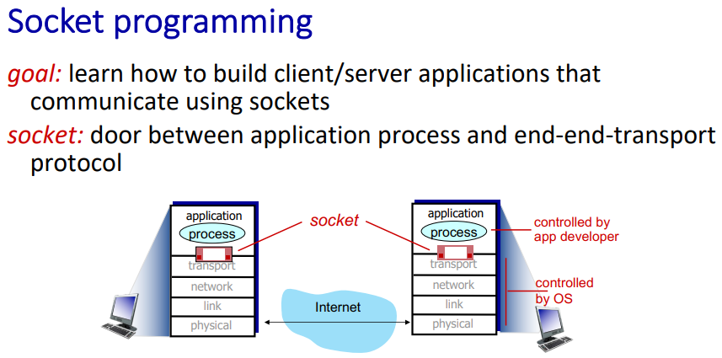

- Know what services TCP and UDP provide

**UDP: unreliable datagram**

**TCP: reliable, byte stream-oriented**